Programming rules

Views

* Do not create SQL queries
* All views must be .blade.php
* To refer to an atribute from an object from the model, you should use the proper methods



* All non-admin views must extend from layouts/master
* All admin views must extend from layouts/admin.master
* Never open and close php tags within views.

Routes

* Every route must be associated with a controller..
* Routes must be declared in web.php module.
* Api routes must be declared in api.php module.
* Routes can not validate, instead.

Controllers

* The validate method must be in the model
* Never echo a controller.
* Controllers must extend Controller

Models

* The validate method must be in the model

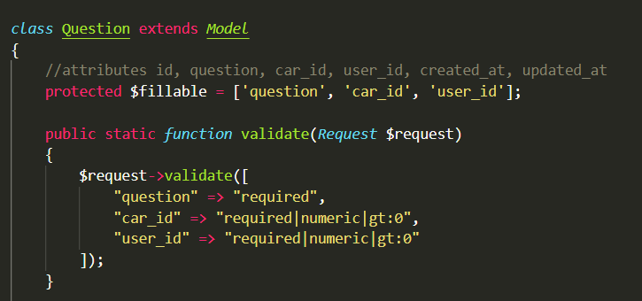

* Models should not redirect to any route

Module declaration

* Try to use the migrations system
* Comply with the DRY principle
* All modules should contain a comment on the top specifying it’s creator

